1. Air after filter

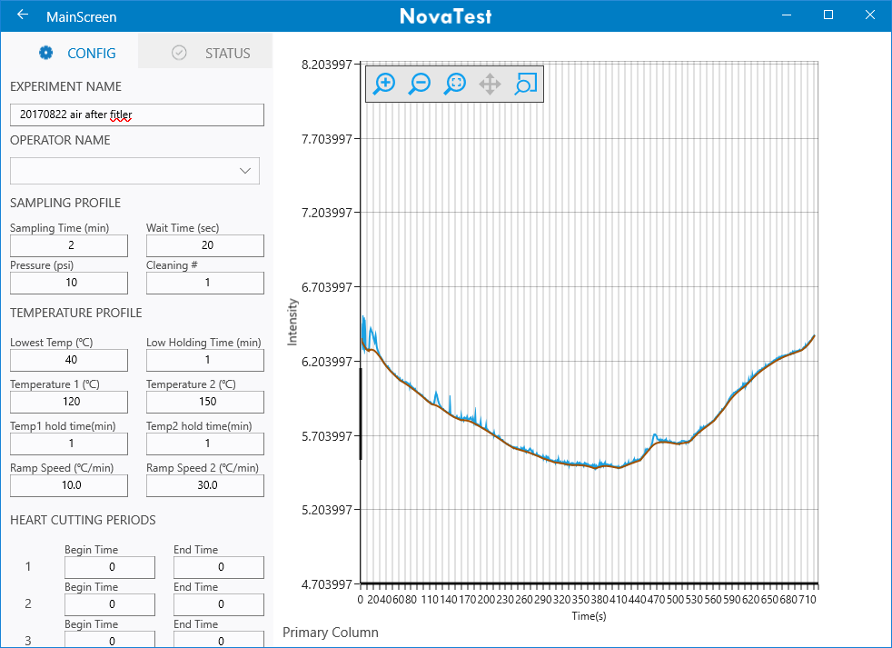

1. Canister test after 10 times wash (contained 2ppm BTEX before)

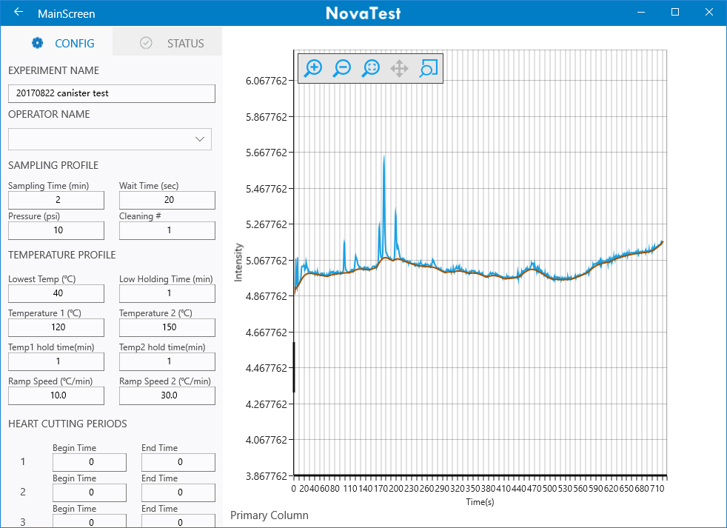

1. 1ppmv BTEX 1min

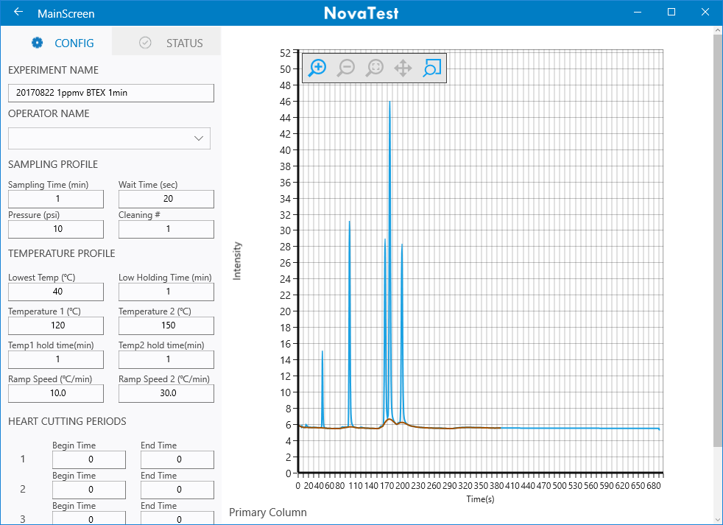

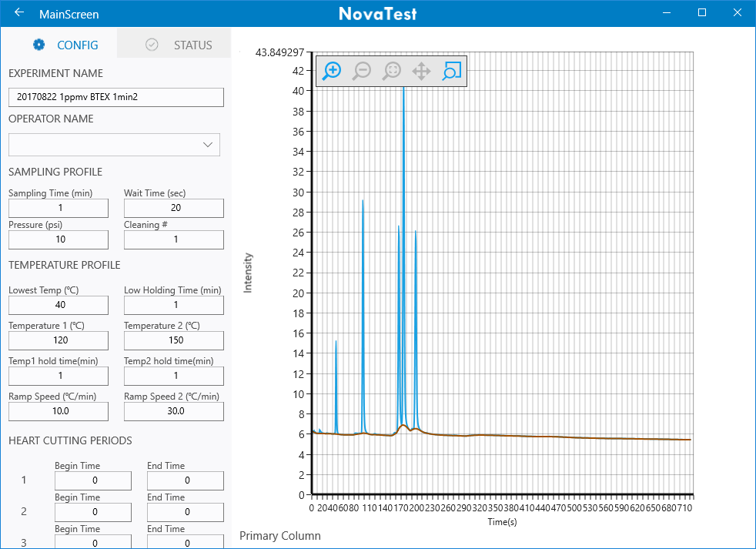

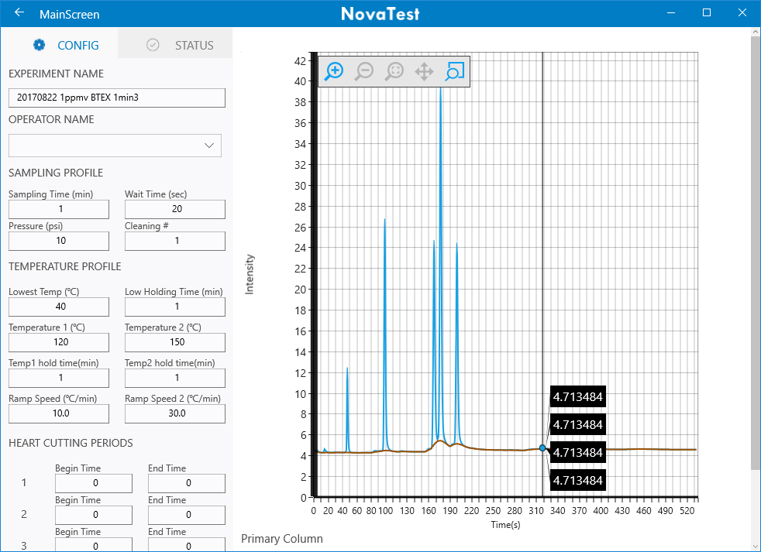

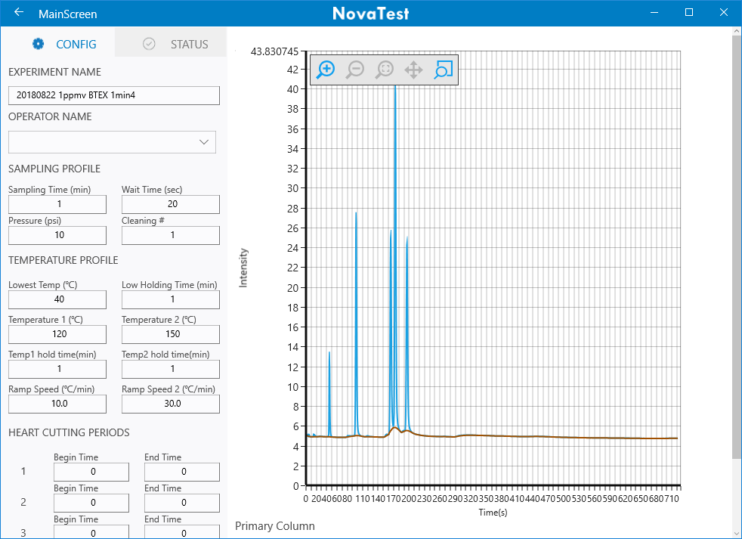

1. TO14

Sampling time 1min; there was one small peak before benzene

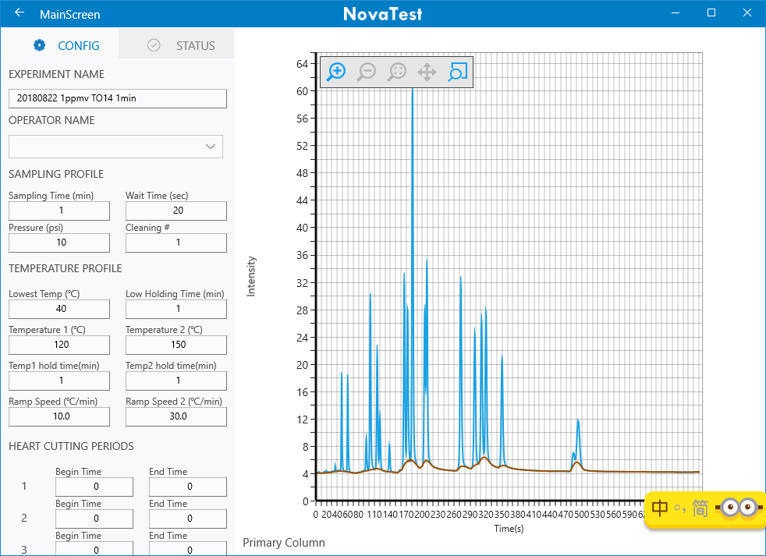

Sampling time: 5 min; no peak before benzene; probably due to compete adsorption. It was hard to adsorption molecules with lower boiling point than benzene

